Iberia Advisory Team Performance Tracker - User Guide

# Step-by-Step Guide: Submitting Your Weekly Reports & Accomplishments

## 1. Start at the Home Page

When you launch the app, you land on the Team Performance Tracker home screen.  
  
- Use the sidebar on the left to navigate.  
- Click Form Submission to begin submitting your report.

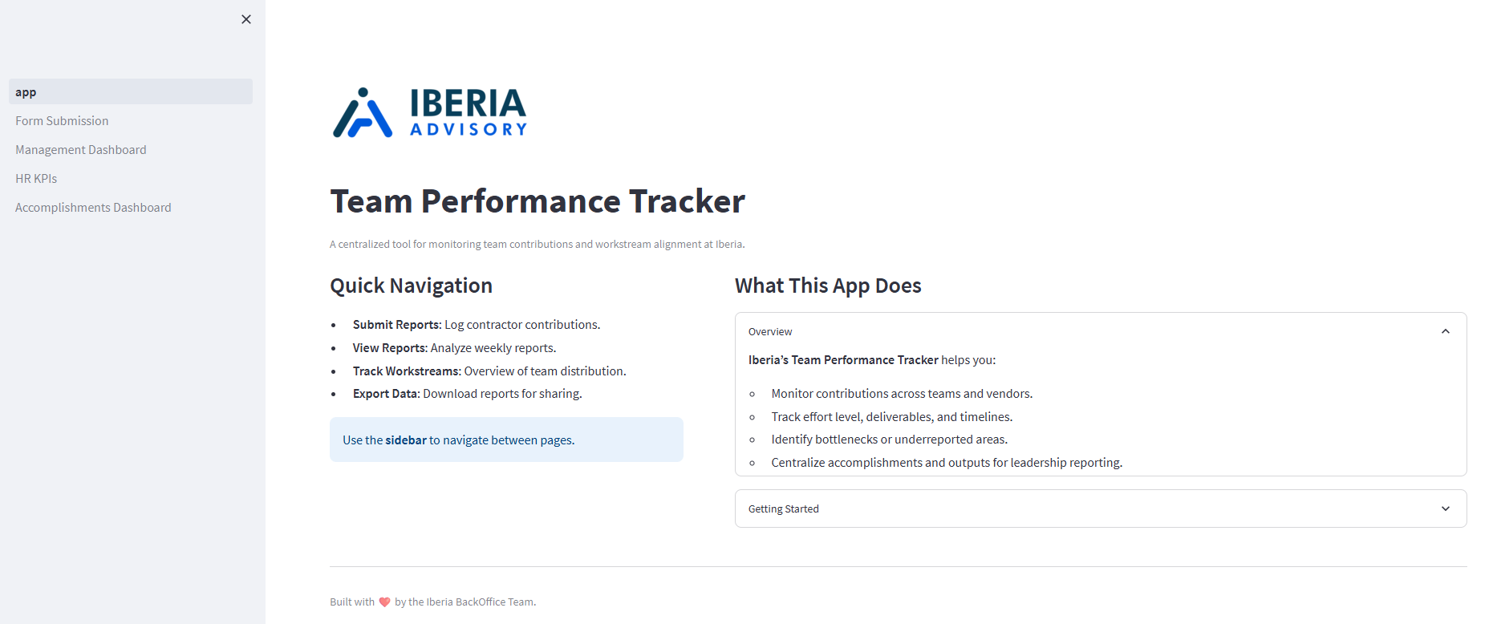

## 2. Fill Out Weekly Reports

On the Form Submission page:  
- Scroll to the Weekly Reports section.  
- An interactive table appears. Each row is for one report.  
- Fill in fields like:  
 - Reporting Week  
 - Vendor Name  
 - Work Product Title  
 - Time Spent Hours  
 - Status  
 - Completion Date (if applicable)  
  
Use Tab to move quickly between fields.

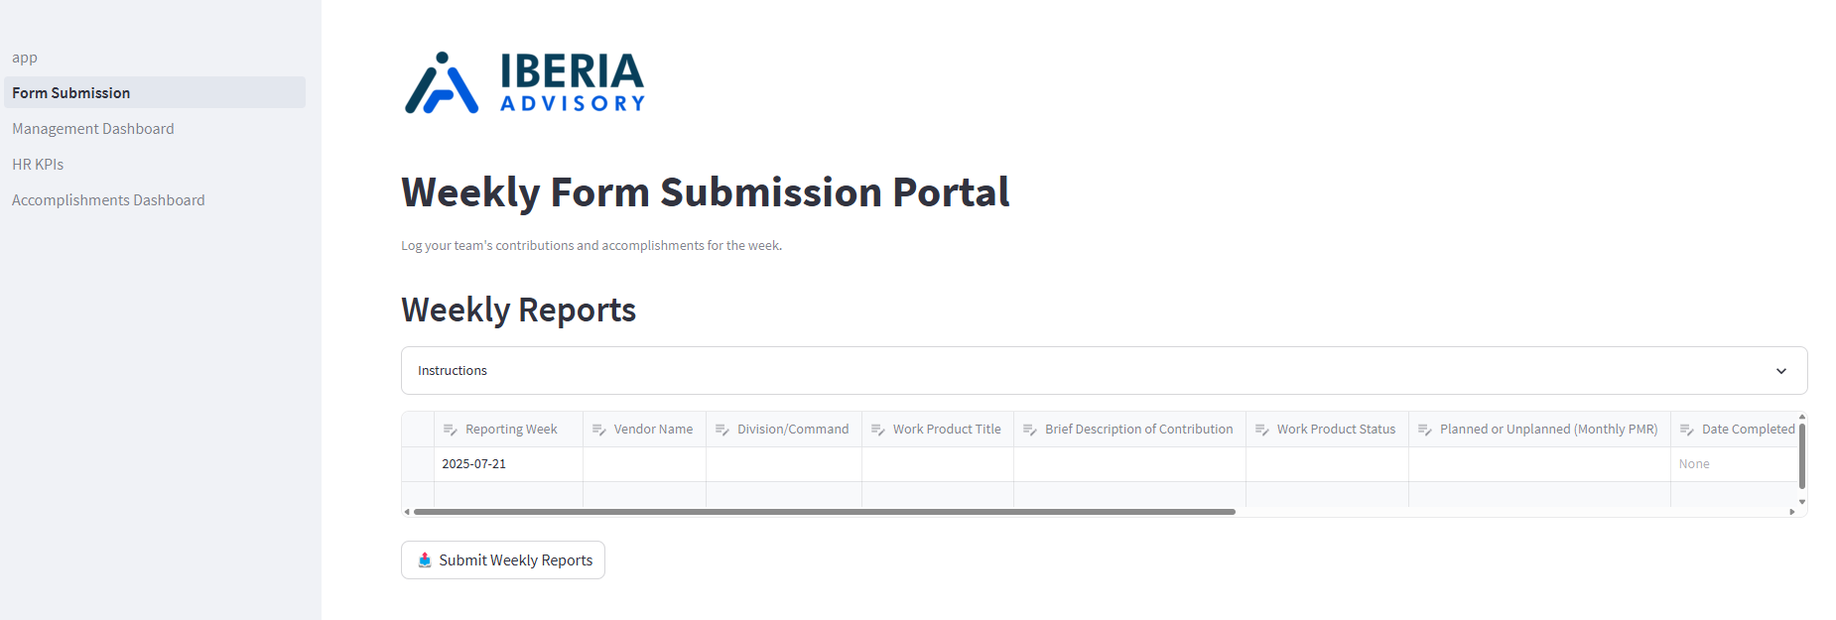

## 3. Submit Weekly Reports

Once your data is entered:  
- Click Submit Weekly Reports at the bottom of the section.  
- A success message confirms your report was saved.

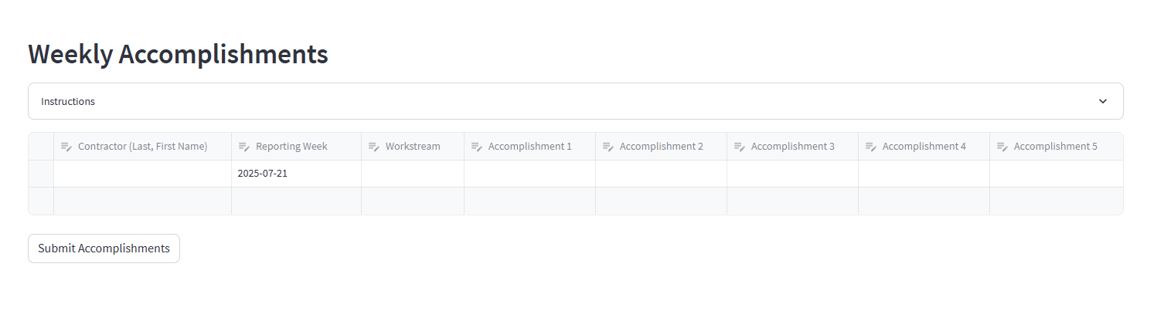

## 4. Log Weekly Accomplishments

Scroll down to the Weekly Accomplishments section:  
- Fill in accomplishments for each team member.  
- Enter up to 5 accomplishments per person.  
- Include workstream and reporting week.

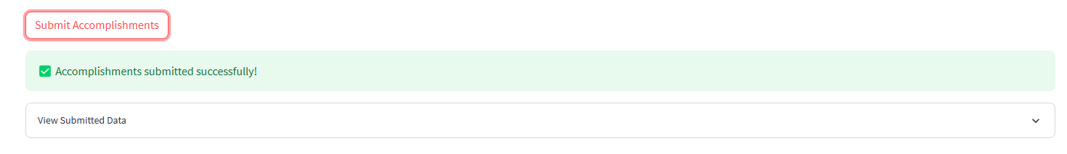

## 5. Submit Accomplishments

- Click Submit Accomplishments.  
- A green message confirms success.



## Tips & Reminders

- Leave blank rows empty they’ll be ignored.  
- Data is saved securely to the backend database.  
- Avoid submitting duplicate entries for the same week.